NAME: _______________________________________ Date: ___/___/______ Period: _____

Elissa (Dido) Legend of Carthage

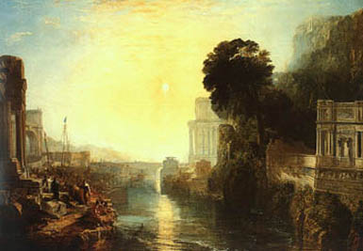
Elissa and the Founding of Carthage
(Dido Building Carthage)
by J. M. W. Turner, 1815

The legend of Elissa, a Phoenician princess from Tyre, tells how she created the great city of Carthage on the coast of North Africa. Surprisingly enough, much of this story turns out to be historically accurate. Unfortunately this legend was recorded by Greek and Roman writers, whose lands fought long wars with the Phoenicians. That led to a bitter description of the king of Tyre, a boy only eleven years of age, who could hardly have done many things told in the story.

Nevertheless, the legend is fascinating. Here it is relayed by the Roman poet Virgil. He uses Roman names in the poem: Aphrodite is called Venus, Elissa is Dido, Acherbas is Sychaeus, and Africa is Libya. Aphrodite tells the story to Aeneas as he arrives on the shore near Carthage.

This that thou seest is [Carthage's] land, by Tyrians peopled;
Here is Agenor’s town; fierce Libyans harass our borders;
Dido is queen of the realm; she abandoned her Tyrian city
Fleeing her brother; —but long are her woes, too long their recital;
Nevertheless, in its broader lines, I will follow her story.
She was the bride of Sychaeus, a man who was counted the richest
Owner of land in Tyre, and devotedly loved by poor Dido,
Whom in her maidenly bloom, her father had pledged in betrothal:
Omens of marriage were bright; but over the Tyrian people
Reigned her own brother Pygmalion as king, —a monster of evil.
Bitter dissension arose in the home, and by avarice blinded,
Disregarding his sister’s love, and defiant of Heaven,
Even at the altar he stealthily slew unwatchful Sychaeus.
Long he concealed the deed, and, imagining many a pretext,
Basely deceived and encouraged the hope of his heart-broken sister.
But in her slumbers the spirit itself of her husband unburied
Came, and uplifting a face of strange and unnatural pallor,
Showed her the blood-stained shrine, and his breast transfixed by the dagger,
Plainly disclosing the secret disgrace of her home and her brother.
Then he adjured her to hasten her flight, and escape from the country,
Telling of treasure long hid in the earth, to aid her departure,
Gold unreckoned in weight, and silver unmeasured in value.
Dido, alarmed by the dream, made ready her flight and her comrades;
Gathered all those to her side who detested the merciless tyrant,
All who were moved by fear. Then, a vessel that chanced in the harbor
Seizing, they freighted with gold, and sordid Pygmalion’s treasure
Floated away on the sea; —and this was the deed of a woman!
Down to this place they came, where soon you will see the majestic
Walls and rising towers of the new-born city of Carthage.
Next they purchased a site, called Byrsa because of their bargain;
Only so much could be bought as their wit could surround by a bull’s hide.
Virgil

Aeneid 1.335-1.368

Elissa and Aeneas go on to have a love affair which ends tragically when he leaves her to continue his journey.

In real life, Carthage arose because of changes in Phoenician society, which occurred before the creation of this great city in 814 BC. The amazing history of Carthage's growth to lead an empire of many rich colonies, and her tumultuous relationship with Greece and Rome, are explored in Chapters 17 – 22 of Phoenician Secrets: Exploring the Ancient Mediterranean.

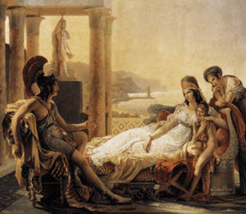

Dido (Elissa) and Aeneas
by Pierre-Narcisse Guérin
c. 1815

Source: http://www.phoenician.org/elissa_dido_legend.htm

