Name: __________________________________________________ Date: ____/____/_______ Period: ______

EARLY HOMINIDS
hominid: ____________________________________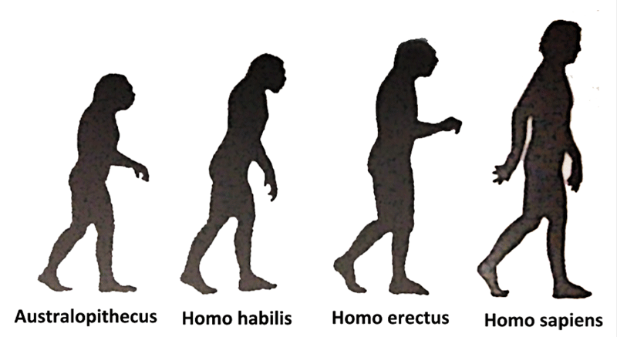

Scientific Name
Meaning
Time
Example

