Headstones Vandalized At Jewish Cemetery In Philadelphia
February 27, 20172:26 AM ET
MARIE ANDRUSEWICZ
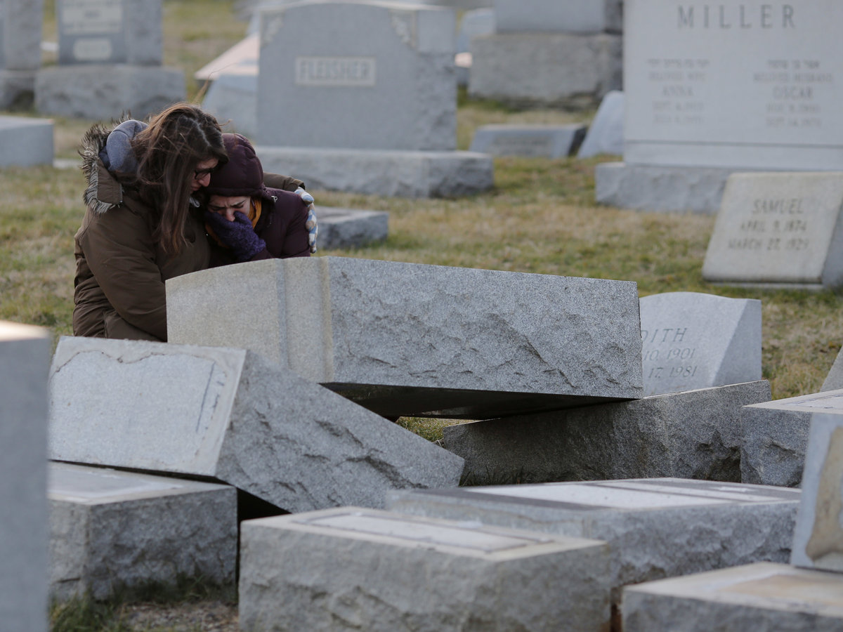
Melanie Steinhardt comforts Becca Richman at the Jewish Mount Carmel Cemetery in Philadelphia. Police say more than 100 tombstones were vandalized a week after a Jewish cemetery in St. Louis was also desecrated.
DOMINICK REUTER/AFP/Getty Images
Philadelphia police say approximately 100 headstones have been damaged at a Jewish cemetery in the northeastern part of the city. The vandalism occurred less than a week after a similar episode in a Jewish cemetery near St. Louis, where more than 150 graves were targeted.
Local police arrived at Mt. Carmel Cemetery Sunday morning after getting a call from a man reporting that the headstones of three of his relatives had been knocked over. A wider search then revealed dozens more headstones had been toppled, in a crime that investigators believe took place Saturday night.
WHYY's Bobby Allyn spoke with Shawn Zevit, a Philadelphia rabbi who described the vandalism as "a hateful act, an attempt to create fear and to tarnish the memory of those who have died and attack their dignity."
Philadelphia Mayor Jim Kenney says authorities are doing all they can to find the perpetrators. "My heart breaks for the families who found their loved ones' headstones toppled," he said in a statement. "Hate is not permissible in Philadelphia."
The Anti-Defamation League is offering a $10,000 reward for information leading to the arrest and conviction of those responsible for the vandalism.
Last week, President Donald Trump addressed recent anti-Semitic hate crimes, including a spate of bomb threats targeting Jewish community centers, calling the attacks "horrible and painful." Trump had previously faced criticism for failing to mention Jews in a statement commemorating Holocaust Remembrance Day.

