Name: ________________________________________________________ Date: _____/_____/_________ Period: _______

ANCIENT KUSH + NUBIA PRIMARY SOURCE STUDY

- Source Sheet 1: take notes on the most important talking points of the brochure.
- Source Sheet 2
  - What are the different explanations for the Deffufa in these sources?
- A fortified temple for Egyptian governor in Upper Nubia.
- A palace for a Kushite king
- A watchtower for ships coming up the Nile
- A replica of an Egyptian temple
  - Which one seems most likely?
Watchtower: there were no mountains so the people built it.
There was also a temple on top of the watchtower so it could
also be fortified temple.
- Source Sheet 3
  - What evidence is there for human sacrifice in Kerma?
Found bones and multiple people in one grave.
May have been buried alive. Large open room = grave.
Multiple burial chambers. Tombs were larger than Egyptian.
  - Why might there have been human sacrifice at burials?
To keep families together in the afterlife.
Possibly to make sacrifices to gods.
Possible religious connection to Egyptians.
Sacrifice may have been based on social status on hierarchy.
- Source Sheet 4
  - The three pictures come from Kush. How much are they copying Egyptian styles?
Sphinx shows people copying idea of half human, half lion.
Ankh = key to the Nile and Egyptian symbol.
Sarcophaguses – show idea of afterlife and preservation of the body.
  - How far do the written sources agree that Kush copied from Egypt?
Sources agree that Kush copied Egyptian culture.
Sources point out that Kush adapted and changed Egyptian style to be more Kushite.
  - Would you agree that Kush did not have an art style of its own?
Although Kushite people borrowed from the Egyptians, because they adapted Egyptian culture, they must have had art styles of their own!
- Source Sheet 5: what skills did Kushite craftspeople have?
Artistic and skilled in pottery. Without a potter’s wheel, Kushite craftspeople made symmetrical pottery was simple or complex designs. Also skilled in metalsmithing and bronze crafts.
- Source Sheet 6
  - What do statues tell us about the power of rulers in Kush?
Powerful figures in Kush had long finger nails and luxurious clothing.
Goods were brought to palaces rather than temples.
Some statues show Egyptian gods protecting kings.
  - What other evidence is there of royal power and control?
Priests in Meroë would decide when kings would die!?
Priests had divine authority. Statues and heads show importance of king.
Kings and priests were powerful.
  - What else can you learn about Kushite society from these sources?
Focus of sculptures was on power because not many sculptures were of common people. Kushite life expectancy was 20-25 years for a king.
- Source Sheet 7
  - Which goods did Egypt want?
Egypt wanted food, gold, copper, precious stones, and eventually iron.
Ivory, animal hide, ebony, and cattle as well.
  - How was Kush useful to Egypt?
When Egypt conquered Kush, they gained access to Kushite natural resources and fertile land. Kush was closer to iron mines. They also enslaved Kushite people
(greater workforce) as well as gained access to more of the Nile and Red Sea.
  - How important was Egypt to Kush’s prosperity?
The Egyptian officials oversaw manufacturing and export trade of Kerma.
Trade with Egypt supported Kushite prosperity as well as Egyptian cultural influence.
- Source Sheet 8
  - What did Kush produce?
Kush produced iron, iron tools and weaponry, grew cotton, and had wine presses.
They raised large herds of cattle. They mined gold and copper.
They produced and shipped raw goods to surrounding civilizations.
  - How was the problem of water solved?
Government oversaw hafirs (giant water tanks) that provided water to areas of Kush that were farther from the Nile. Regulation established and maintained order and made water distribution more fair.
  - What evidence is there that the state organized the economy?
They established a redistribution system and community ovens. They collected surplus as taxes. Those who did not contribute did not receive from it. They also regulated the iron industry.
- Source Sheet 9
  - Describe what is happening in the picture:
a Kushite burial for an important person outside of Kerma (Defuffa in banckground).
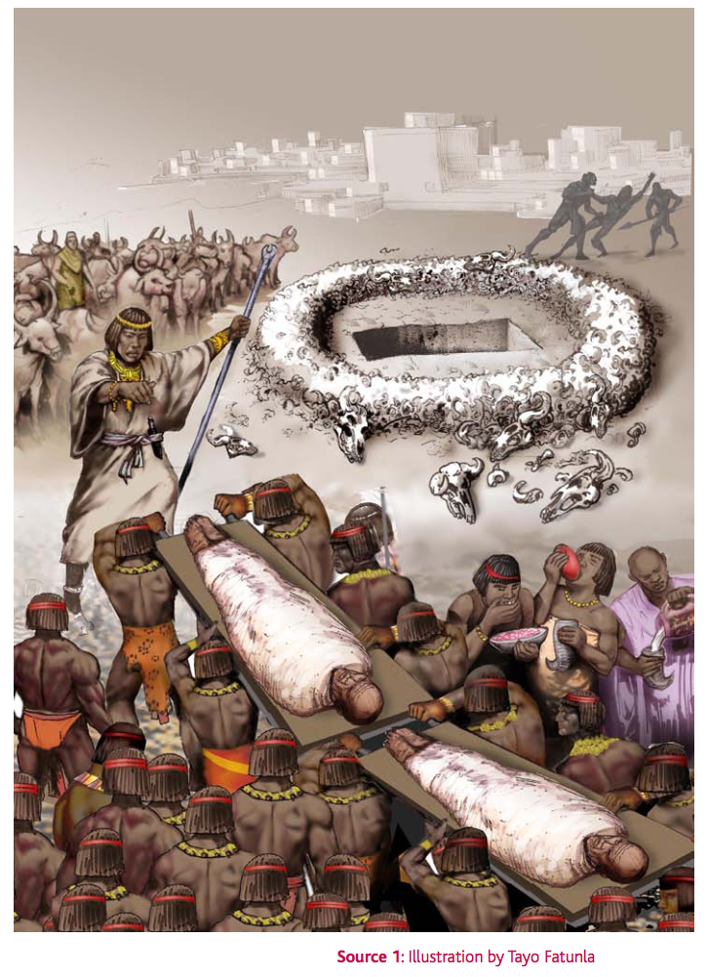
  - Is everyone happy to be accompanying the King into the tomb?
No. In the back, someone is being killed who is resisting. The man in charge seems to be yelling by his facial expressions.
  - What does this tell you about Kushite society?
Human and cattle sacrifice happened in Kush when powerful people died.
Most Kushite people are dressed similarly so this may show hierarchy.

